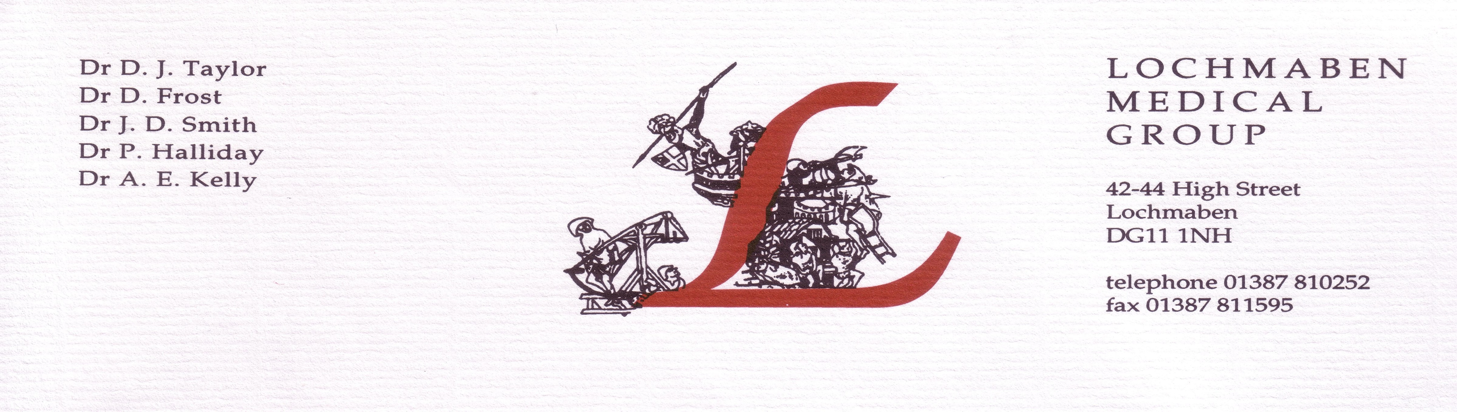 **Lochmaben Medical Group**

**Dr F M Jefford 42-44 High Street**

**Dr N Hassan Lochmaben**

**Dr N J Brown DG11 1NH**

**Dr M E Miller**

**Tel: 01387 810252**

## Internet Appointment Booking Facility

As from 1st March 2017, Lochmaben Medical Group is introducing online Patient Access, giving patients the opportunity to book a doctors appointment online as well as requesting repeat prescriptions.

If you are interested in registering for this new service, please complete the undernoted information and return this letter to a member of the reception team. A Registration information letter will be made available to you from 1st March 2017, to enable you to set up your online booking account.

Once you have been provided with the instructions on how to register you only have **14 days** from the date printed on the letter until the registration details expire.

Once you have registered your account you will be able to book your own appointments and order any repeat prescriptions. Please note that the practice will still require **48 hours** to process prescription request. In the event that you forget your User ID or password, you can use the Forgotten Password and Forgotten User ID features to help recover your details. The Practice will require an up to date email address and mobile telephone number.

|  |  |
| --- | --- |
| Name & Address | Date of Birth |
| Email Address | Mobile Telephone Number |